Vampires, vampires, vampires

Vampire is one of the most popular and beloved character of the American mass culture. Not an American invention but it was in Hollywood where blood suckers were warmly welcomed and turned into film stars.
The vampires came from Eastern Europe, where they always were a part of the local folklore, there are many tales about blood sucking creatures in the Slavic folklore. British writer Bram Stocker traveled to Romania in the mid 19th century and quite by chance heard a local story about a vampire, back home he wrote his famous novel DRACULA introducing the mythical creature to the English speaking public around the world.

When cinema was invented vampires soon came to become an important part of the industry since the films about them appeared to be very popular and bring in lots of money. The first vampire “talkie” was made in 1931 with Dracula being portrayed by Bela Lugosi who set a standard of playing the character. His performance was so powerful and credible that it was endlessly imitated by other actors for many decades

Perhaps the best known actor to have played Dracula is Christopher Lee who practically became the character having performed the part more that 50 times (still a record) in cinema and on the stage.
His most famous appearances include
THE PRINCE OF DARKNESS (1966), DRACULA 72 (1972) and DRACULA RETURNS (1973).
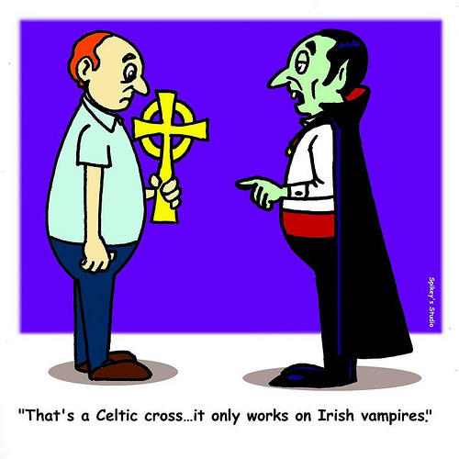
The influence of these films on public perceptions of vampires is enormous including sleeping in coffins, daylight and cross fearing. The vampires do not reflect in mirrors and can not enter your house until you invite them in.

The things started to change in the 1970s. The 1979 comedy LOVE AT FIRST BITE showed a completely new side of the character. A depressed vampire goes to New York to find a girlfriend and in a night club he meets a woman who undergoes psychoanalysis because she always “falls for the wrong guys”. A huge hit at the box office the film is still very popular on TV.

The 1980s saw the vampires invade the territory from where they were previously banned: teenage films.

In 1985 FRIGHT NIGHT came out. A comedy/action flick tells a story about a boy who suspects his new neighbor to be a vampire. Of course nobody believes him (fools !)
A very successful film it has developed a cult following over the years and nowadays is regularly screened at Horror Film Festivals.
It was remade in 2011.

The 1987 drama THE LOST BOYS tells us about a gang of teenage vampires terrorizing the neighborhood in a small Californian town. The film set a boxoffice record and spawned several sequels. Still regarded by many as one of the best “vampire films” ever.

In the 1990s a string of successful vampire movies got the crowds of genre fans fill the cinema theaters to the capacity.

A 3 part BLADE series about a vampire haunter, INTERVIEW WITH THE VAMPIRE, DRACULA 2000 to name just a few.

The direct to DVD and made for TV films are innumerable.

With the 21st century a new era began.
Phenomenally successful series like TWILIGHT and VAMPIRE’S DIARIES introduced a brand new kind of character: vampires are no longer scary. They are loveable guys next door. They don’t even have fangs and dot not have to kill for food.
Millions of girls around the world went crazy about them.

For those who still favor more traditional approach there are true to the canon films like 30 DAYS OF NIGHT (2007) and its 2 sequels – a frightening story of a city in the North of America being attacked by a gang of vampires during a month-long Polar Night – or STAKE LAND (2010). Dracula was presented as comic character in the 2012 smash hit HOTEL TRANSYLVANIA.

Why are vampires so popular after all?

The most universally accepted answer is: it’s all about public infatuation with the idea of immortality and eternal youth.
The dark mythology of vampirism is thrilling:
- to drink blood
- to run away from the daylight
- to sleep in a coffin
- to live forever

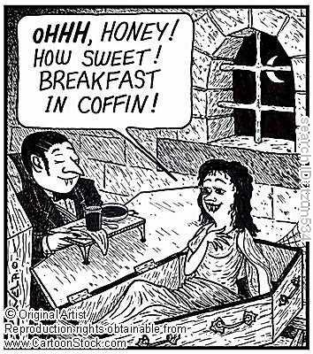

However strange these things may appear to many people there is always a relatively large minority of those who find them exciting and cool.

